Assignment-3
Mohammed Numaan Ahmed
2503B05127

Task:1

Problem-01:

A bit stream 1101011011 is transmitted using the standard CRC method. The generator polynomial is x⁴+x+1. What is the actual bit string transmitted?

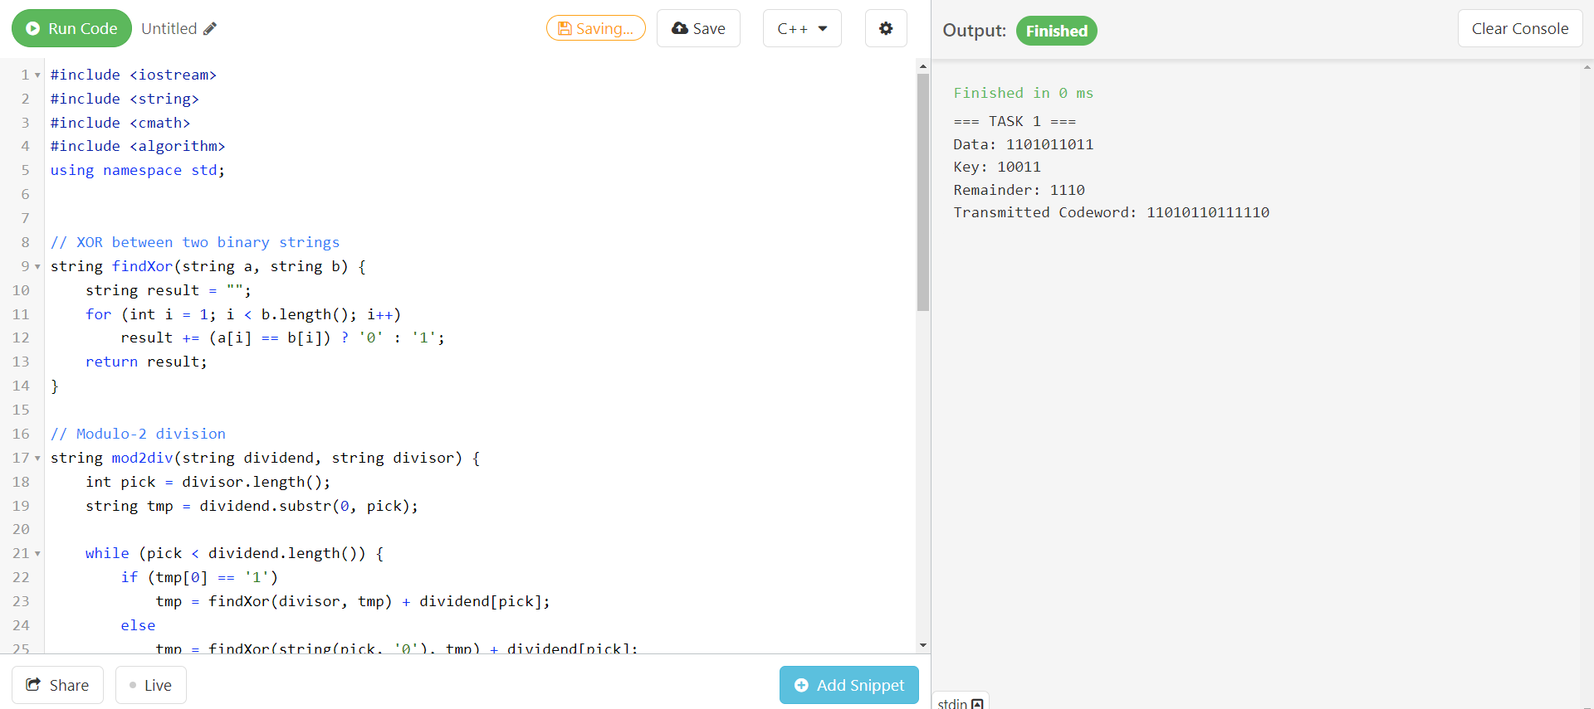
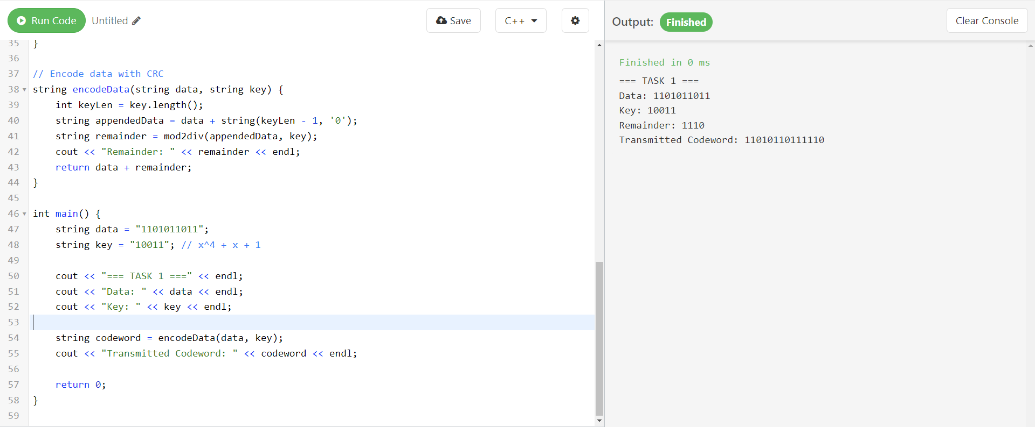

Task:2
Problem-02:
A bit stream 10011101 is transmitted using the standard CRC method. The generator polynomial is x³+1.

- What is the actual bit string transmitted?
- Suppose the third bit from the left is inverted during transmission. How will receiver detect this error?
